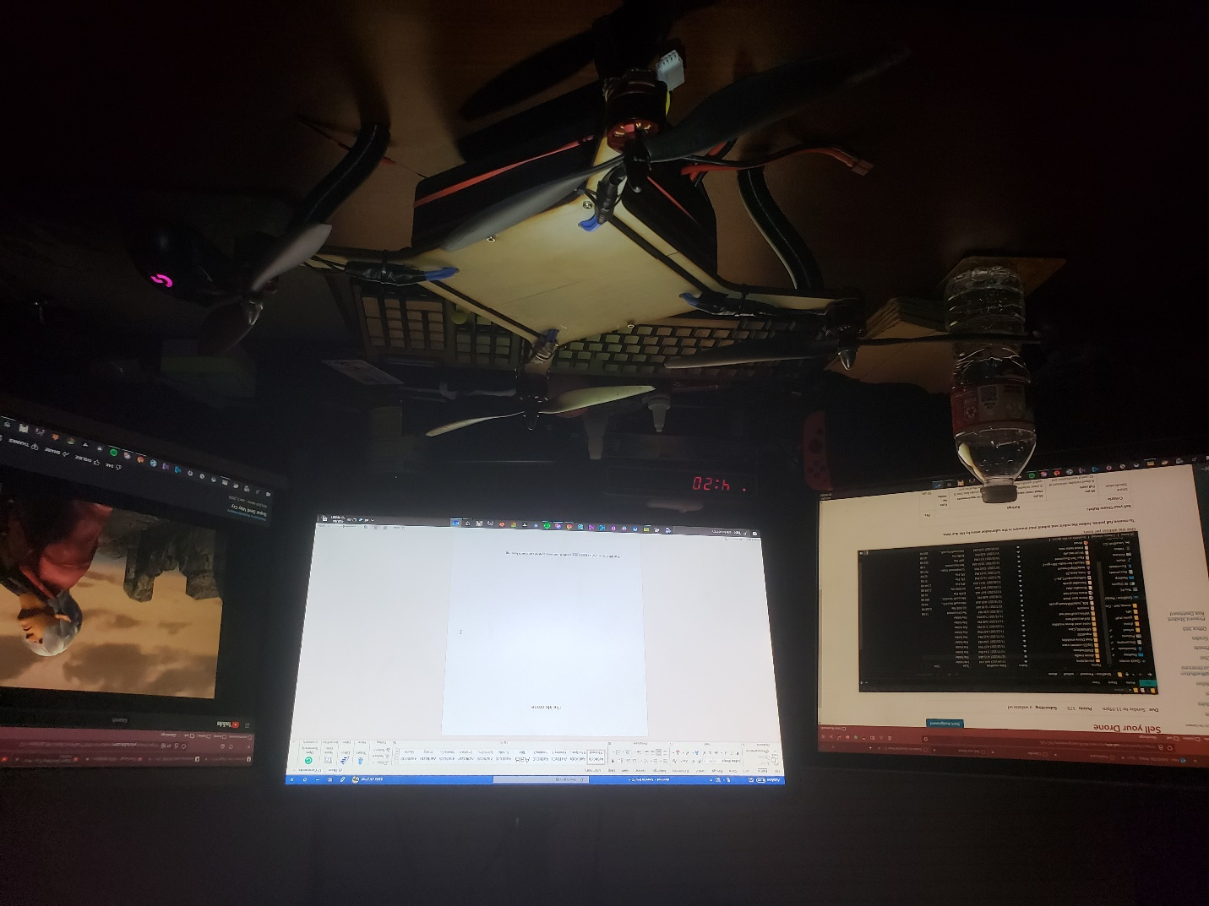The idk drone

The idk drone is what every one wants it has easy controls and auto leveling

dmblade.github.io/drone vods.txt

<https://youtu.be/w4CIrONqF2s>